Free Scientologists
Andreas Gross, C.E., Morgarten, Switzerland
FS Bulletin 14. July 2020 I
Translated to English 1. June 2022

Solo course for OT III
BPI

The Most Obvious Flaw on the Solo Levels
No one wants to confront the most obvious outpoint in the delivery of solo levels in both the CoS and the Freezone: The delivery org doesn't because it would collapse their income and the clears don't because they shy away from the effort, preferring it quicky even if it kills them:
The Solo Auditor's training is based on SHSBC Levels 0 to VI, but the VI Level materials have not appeared on the briefing course since early 1972.
As early as May 5, 1972, SHSBC Level VI was eliminated by Brian Livingston and replaced by a pseudo-level: see this scan of the 40 page checksheet HCOPL dated July 8, 1970, revised May 6, 1972:
HCOPL 700708 (720506) Saint Hill Special Briefing Course Class VI Checksheet.pdf.
The stated product no longer contains any reference to Level VI materials as it used to:
A Class VI auditor who can flawlessly apply the tech of Scientology grades, their set up and repair
Since this is hard to believe, I show you the sections of the 40 pages Checksheet:
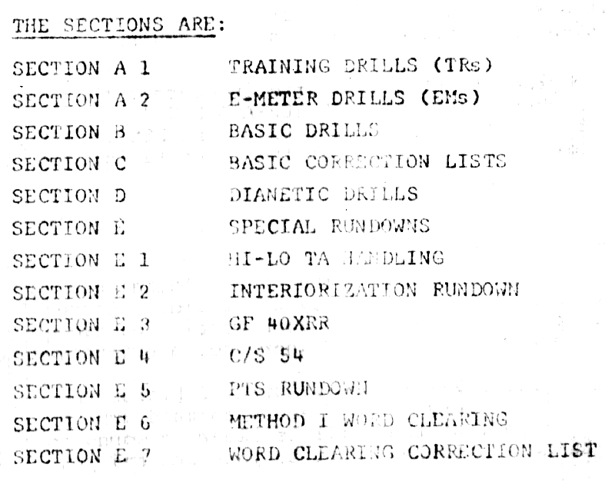
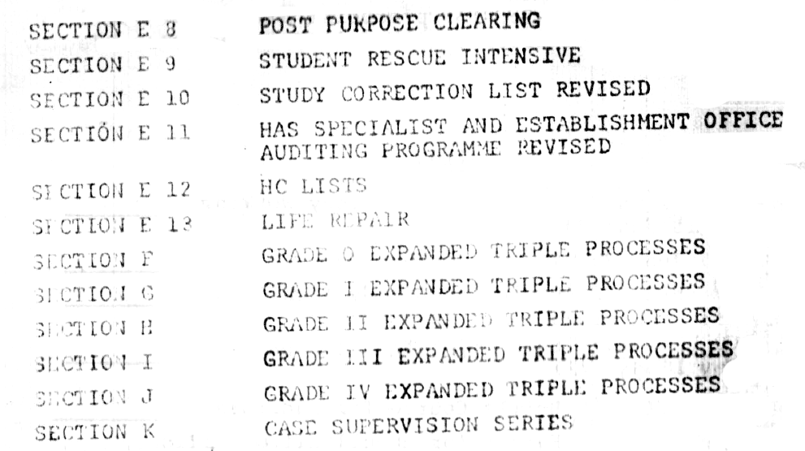
The original SHSBC Checksheet for Level VI (see file PL671205 SHSBC Checksheet 1967 Level VI scan.pdf) entitled "Whole Track Materials and General" had only 11 pages, 4 pages were Confidential Materials, which have not been available in the CoS since 1972.
Up to this date May 1972, one could only get onto the solo levels as a SHSBC graduate.
When Ingo Swann produced the scientifically irrefutable proof at the CIA that the OT ability "stable exterior with full perception" is reality and not a fraud and is not, as before, only a rarely occurring phenomenon of "enlightened people", but is now systematically attainable via the bridge by "assembly line work", there was only one handling of this danger for the CIA a.o. elements of the Deep State: the elimination of these OT levels and clearing.
Details of how this scientific proof of the OT-EP - also called Remote Viewing - came about can be found in the book The Untold Story Behind the US Government's Takeover of Scientology.
Close to the time of the disappearance of L. Ron Hubbard around June 1972, this modified SHSBC checksheet was brought out, probably already in view of the certainty that LRH would soon no longer be able to intervene against it.
Instead, since then, solo training has been made quicky in the CoS and also in the Freezone: all that is needed is some auditor course (the HQS course is already sufficient for this) and then Solo Course I and II, which contains none of the Level VI material and thus leaves the solo auditor without any auditing experience and without the Level VI materials and often also without any practice in Dianetics on his own case. Failure is then inevitable. It is amazing that only about 60-70% of the people on the OT levels become seriously ill or die (according to my count of 100 solo auditors personally known to me, whom I had met in the RTC-CoS and from whom I knew some medical data).
It also doesn't seem to bother anyone that LRH specifically points out that solo auditing will fail because of this.
I quote one LRH handwritten 7 pages note about OT III. C/Sing data, not included in OT III solo pack:
Section Three – 15/2/68
Additional Tech Data
There are no Body Thetans who cannot be audited and exteriorized.
- There are Suppressive Body Thetans who require Power Processes.
- There are difficult Body Thetans who require 0 to VI processes before they can run engrams (Inc 1 & Inc 2).
- There are PreOTs who are insufficiently trained and who cannot audit and who ARC brk or overrun Body Thetans or who cannot do Academy Level 0 - IV auditing much less Level VI auditing.
- There are Clusters of body thetans who think they are one Body Thetan and so can't run Inc 1 or Inc 2 as a group as they have differences.
[second page - marked -2-]
- SP Body Thetans
An SP by definition is one who is out of valence in R6. Some are just plain psychotic and SP as well. PrPr 6 handles any SP, pc or body thetan.
This can best be done, by actual Test, by the OT being an SH or AO Class VII. It can possibly be done (no test ever made) by having a Class VII audit the OT who relays the commands to and answers of the body thetan to the auditor, the OT being on a Meter; The meter will respond to the body thetan if the OT is putting attention on the body thetan. This HAS been done with ordinary body Thetans. It simply handles The Body Thetan on a via.
When PrPr VI has been run on the body thetan to its end phenomena, the body thetan can then
[page 3 marked -3- Sect III Add Tech Data]
be handled as an ordinary pc body thetan as in 2. below.
- Difficult Body Thetans
Some body thetans are difficult cases. They are psychotic, or they have fixed ideas or service facs.
To handle, one really should be a Class VII. However, an OT on Sect III can be used as a relay to and from the body thetan and audited by a Class VII. There is no substitute for being an SHSBC graduate + a Class VII Interne.
Only standard Scn Tech is used, no Tricks needed. The auditing is fast. The needle seldom floats on the body thetan and the TA tends to start high and come down.
When the Body Thetan has been pushed up to IV (grade Four) he can usually run engrams and
[page 4, marked -4- Sect III Add Tech Data]
can be run on Incidents 1 and 2 and will blow.
The trouble with a difficult body thetan is that he (or she) usually has some fixed idea which inhibits his recovery. This responds to ordinary tech, taking him up through the grades.
- Insufficiently trained OTs
Some students try to run engrams like Clearing Course materials or make other errors because they are just not well trained. Such should knock off III and do a Dianetic Course at least or even the SHSBC. If they still have trouble they should Interne as Class VIIs.
THE MAIN SOURCE OF FAILURE IN SECTION THREE IS NOT STRANGE THETANS OR HIDDEN SPs BUT STUDENTS WHO CAN'T AUDIT.
[page 5 - marked -5- Sect III Add Tech Data]
It is easy to blame the "difficult body thetan" when the truth is that one should be a better auditor.
Sect III can be left incomplete while the student is trained better – providing he does not fool about with his own case while being trained but, now trained, recommences Section III.
One has to be able to do S & Ds on Body Thetans, has to find ARC Breaks, etc, the lot, where one has trouble with Sect III.
The number of body thetans a case has varies widely.
The answer with consistant trouble with III is not unusual solutions for body thetans but just a better trained student. Body thetans are just thetans.[page 6 marked -6- Sect III Add Tech Data]
- Clusters Of Body Thetans.
The only known difference between auditing body thetans and auditing pcs (and it is not a real difference as some pcs are a total cluster) is that body thetans can come in clusters.
Then Inc 1 won't run on the cluster as each individual thetan in the cluster has a different viewpoint and received Inc 1 as an individual, not as a cluster.
A CLUSTER HAS A MORE RECENT MUTUAL EXPERIENCE WHICH HAPPENED TO THE WHOLE CLUSTER.
The error they make is the basic error of thetans. They think we are all ONE, whereas we are individuals.
[page 7 marked -7- Sect III Add Tech Data]
To detect a cluster (a) There is a force or pressure or heavy somatic in an area (b) or there is "a thetan" who can't erase Inc 1 or 2. This means there are several thetans who think they are one thetan.
To remedy this situation
- Date a mutual incident for the cluster to find the point they "became one". Usually one gets this easily.
- Locate where it occurred in terms of planet and star (or even planet, star, town, and place in the town.
- List for a type of incident and find what it was (lightning, psychiatric shock etc)
- Run the incident as a single engram.
This is the full 7-page LRH manuscript on OT III, 15 February 1968 Section Three - Additional Tech Data. It also exists as a photo copy of his handwriting, also ending abruptly after the 7th page without LRHs signature.
In the above issue he tells us which processes are to be audited and from this it is clear that an untrained and inexperienced auditor is completely overwhelmed by this.
The alter-is of the checksheet proves it that the takeover took place in the summer of 1972 and was a hurried reaction to the evidence that OT was real and that since then an urgent PsyOp operation has been done to eliminate Clearing and OT:
Psychological warfare (PSYWAR), or the basic aspects of modern psychological operations (PsyOp), have been known by many other names or terms, including Military Information Support Operations (MISO), Psy Ops, political warfare, "Hearts and Minds", and propaganda. The term is used "to denote any action which is practiced mainly by psychological methods with the aim of evoking a planned psychological reaction in other people".
Various techniques are used, and are aimed at influencing a target audience's value system, belief system, emotions, motives, reasoning, or behavior. It is used to induce confessions or reinforce attitudes and behaviors favorable to the originator's objectives, and are sometimes combined with black operations or false flag tactics. It is also used to destroy the morale of enemies through tactics that aim to depress troops' psychological states.
Target audiences can be governments, organizations, groups, and individuals, and is not just limited to soldiers. Civilians of foreign territories can also be targeted by technology and media so as to cause an effect in the government of their country. [From Wikipedia]
Our logical conclusion is to restore the original line of training for the OT levels and that means:
The SHSBC with the checksheets from 1967 up to and including Level VI is the prerequisite for starting on the solo materials: starting with R6EW through the Clearing Course and OT I to VII (of course the original levels, not NOTS).
I can not recommend the quicky way, which LRH also mentioned (HSDC instead of SHSBC) as too many Scientologists are dying on the OT-levels, probably due to lack of training.
Have fun on the properly done OT Levels!
Andreas Gross
for the
Free Scientologists
Copyright © 2020, 2022 by Andreas Gross, C.E., All rights reserved.

Most solo auditors have not attended an academy and have no experience with duo auditing, so this is usually violated today.

